## Merchant

Scoping start date: N/A

Implementation Completed Date (Go live date): N/A

MSA Signature Date: Mar 31, 2024

GTM POC: Royce

ERP: NS

Tax Integration: No Tax

### 

### Key people at Merchant

### Accountant: [Mike Lawrence](mailto:mike.lawrence@redantler.com)

### CFO: [Rich Pacheco](mailto:rich.pacheco@redantler.com)

### 

| **AE/ Implementation Notes Sections**   * Info on how merchant bills   + [Red Antler Implementation](https://docs.google.com/spreadsheets/d/1GxGaqPrG6WxO9CFShZSYWgSQOBv8V6aXt579OcFjYSc/edit#gid=0) * Project ID set up   + [Fat Earth | Project IDs](https://docs.google.com/spreadsheets/d/1ZYQj-8D2fOUFk1gyQ1NnHF5Wc1tl66eBPOrFIlJldY0/edit?gid=1476667962#gid=1476667962) - EXTERNAL {Do not touch}   + [[Tabs Internal use] Fat Earth | Project IDs](https://docs.google.com/spreadsheets/d/1PVtCuHVuWo0s4ilZbv1O2ci2vdudx8CmbgH6_YYfIBM/edit?gid=1476667962#gid=1476667962) |
| --- |

### 

### Company summary

Red Antler LLC provides marketing services. The Company offers research, branding, naming, digital designing, engineering, and advertising services.  
  
AM Notes

* Larger / Enterprise account for Tabs (ACV ~$40k)
* [Red Antler x Tabs | 2024 Planning convo](https://docs.google.com/presentation/d/1ISWuZU_sYD0hub1f_xIx183UWOWO7SqNerHZya9j-QY/edit#slide=id.g2a644c08149_0_22)
* [Red Antler x Tabs | 2024 Partnership Follow up](https://docs.google.com/presentation/d/1we1EdoWMyJrpFU-_pXjo054_JjzRnW5TrKs-JQl742c/edit#slide=id.g2ade9637bdc_1_0)
* [Red Antler - Contracts onboarding](https://docs.google.com/presentation/d/1rLnjHlr7ctj43DdQePyK4MSZd7co19MM-Ri6wGX6ISY/edit#slide=id.g2b590538859_0_83)
* [Red Antler - Description of Process.docx](https://docs.google.com/document/d/12lLuWc4reAQujnH98s-fRLztLe4-MCf_/edit)
* [FAT EARTH Billing Process](https://docs.google.com/document/d/1kHSUF6o9fSM5-3wHyazOU8-GT4FCi9DnAiXnWhJTTkk/edit)

### Billing model

—---

For **Fat Earth**

### Contract Processing Steps

For renewal contracts, process all BTs under the renewal contract.

**\*\*\*Contracts that already have a Sent /Paid invoice cannot have their Billing Terms changed.** New Edits / Additions / Requests from the merchant will have to go on an entirely new contract and will be on a separate invoice

* When you see a sent invoice on the contact in garage, ask the US team to duplicate the contract to put the new BTs under
* Customer
  + GL connected, Please search for a customer and select existing customer in dropdown
  + If there are duplicate customers with the same name go to the customers tab in Garage and search the customer. Use the customer ID associated with the Fat Earth merchant.

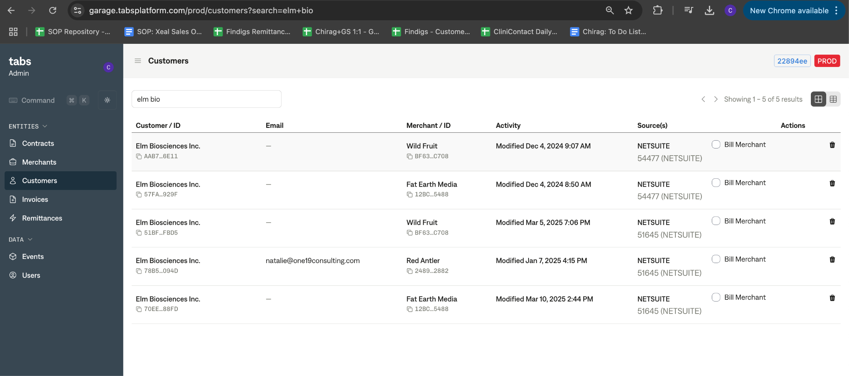

* + If still unsure what customer to select, flag Ops Team [Chirag Manyapu](mailto:chirag@tabsplatform.com)
  + If customer doesn’t exist, please reach out to CSM (Royce as backup) to ask the Fat Earth team to create a customer
* Billing cadence: Monthly
* Default Payment Terms: Net 0 (if not listed in the contract)
* ***Default service term - ignore contract terms***
  + Always create 12 invoices or in increments of 12, e.g., 12, 24, 36, etc
* ***The invoice start date should be in the 1st of the following month***
  + I.e, if first invoice dates is Aug 22, 2023, the invoice should be updated to Sept 1, 2023
* GL connected, Please search for a customer and selected existing customer in dropdown
  + If no customers are found, please create a Tabs customers
* Integration Items:
  + Mark all integration items as **Retainer**
  + For any overage that Red Antler billed, they will use “**Media Fee**” (this will likely be created as a one-off items, and Red Antler will add these correctly)
* Project ID
  + (1) Mike will create a project ID for any new customer
  + (2) Sync Project ID via Garage secrets
    1. Set Red Antler Project ID super power
    2. Add Contract ID
    3. Add Project ID
  + <https://www.loom.com/share/d85fc7f90fff4856b40941149775dca5>
    1. Loom Video for setting Project ID
  + (3) If project ID is not created follow the Project Creation Workflow below
* Payment method
  + The merchant is defaulted to **ACH credit**
  + 5 legacy customers should have **CC payments**
    1. Alison Lou
    2. Mod Bikes
    3. Ossio
    4. Velotric
    5. Waterlust
    6. Feals
* **Summary of Payment Config by Customer:**
  + Credit Card should be turned OFF
  + Review by checking & confirming it on the invoice PDF
  + List of customer ID are associated with the selection (when that change, we need to update it and reset payments) - csv [here](https://docs.google.com/spreadsheets/d/1GxGaqPrG6WxO9CFShZSYWgSQOBv8V6aXt579OcFjYSc/edit#gid=1758720094)
* Ops to send slack bot notifications once processed

### 

### 

### —--

### Events Processing (if necessary)

* Any important information on events billing

### Customer Information

* Any important information on specifics customers of this merchant
  + Special memo’s certain invoices require
  + Invoice changes due to merchant/customer relationship

### Feature Requests

* FR 1
  + What is it
  + Why it's important
  + Urgency

### Rewatch Calls

* Rewatch by dates